**Lab 5**

**Create a new workspace and use the productsdb script provided in eLearning. For each problem, enter your query and attach a screen shot of the result set. Each problem is worth 3 points.**

1. **For each product, look at the QOH and determine what percentage the QOH is of the total products on hand. Display the product code, description, p_qoh, total QOH – for all products, and percent of total QOH as a percent. Order by the percent in ascending order.**

**SELECT line subquery – attribute list subquery**

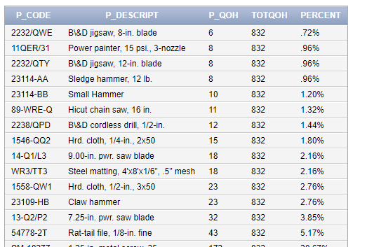

**select p_code, p_descript, p_qoh, (select sum(p_qoh) from product) as "TOTQOH", concat(round((p_qoh / (select sum(p_qoh) from product)) * 100, 2), '%') as "PERCENT"**

**from product**

**order by PERCENT asc**

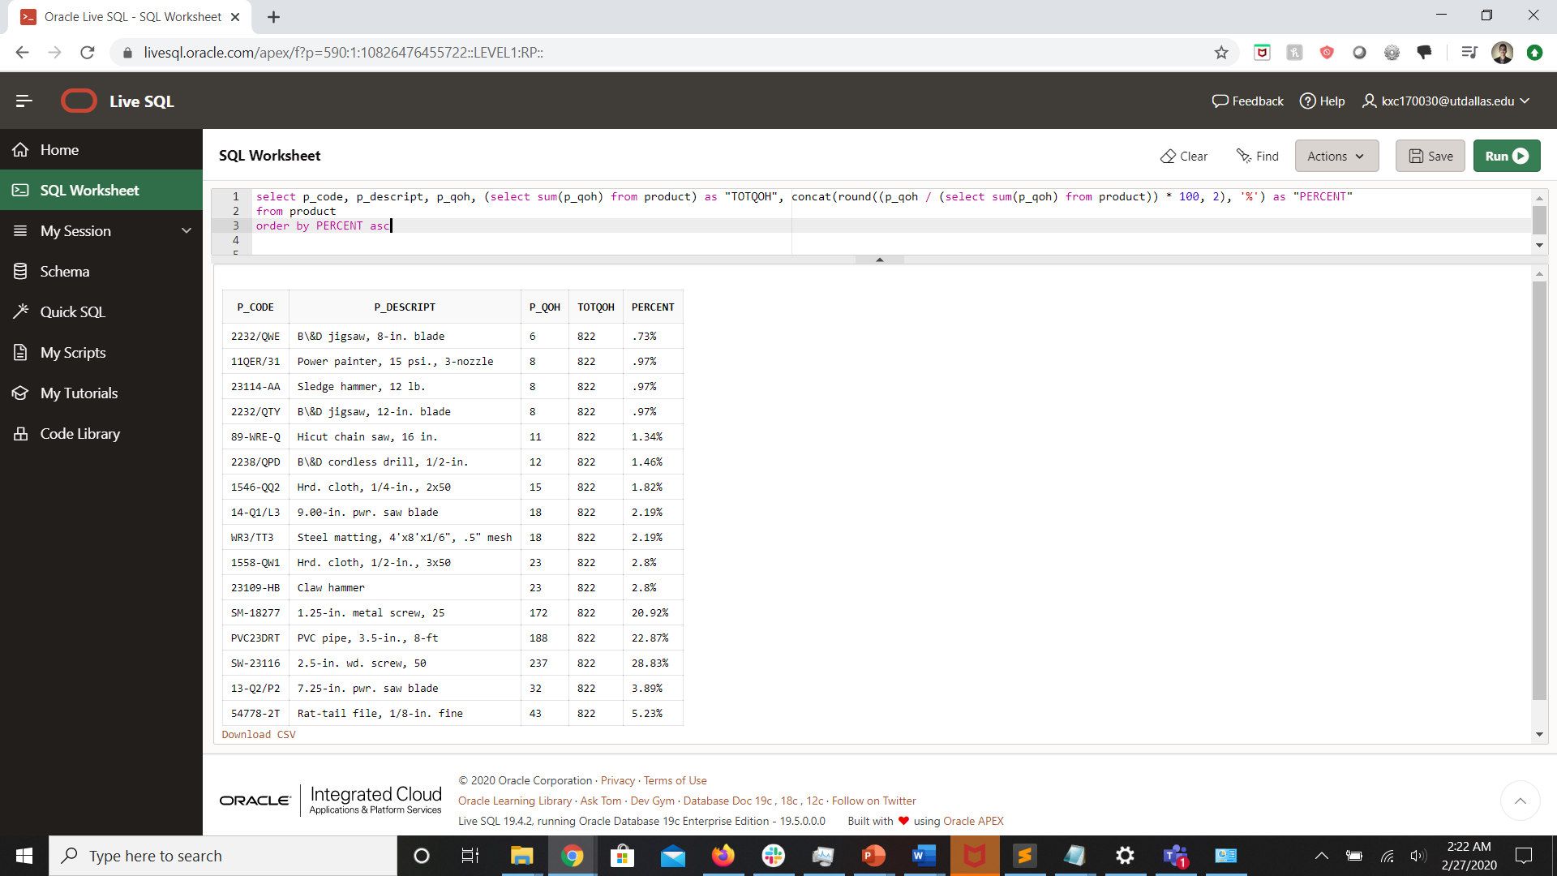

INCOMPLETE – how to concatenate percent sign

1. **Display the overall marketshare for each product. Show the overall marketshare for each product in terms of dollars sold and items sold. Show this as a percent. To determine marketshare you need to do the following:**

**To determine the %sold - For each product, you need to take the total units sold for that product and divide that by total units sold for all products.**

**To determine the %Profit – For each product, you need to take the total profit for that product and divide that by total profit for all products.**

**FROM subquery – inline view**

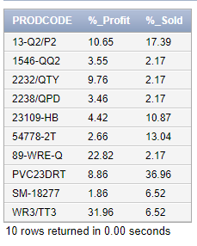

**select p_code as "PRODCODE", round((sum(line_units * line_price) / (select sum(line_units * line_price) from line)) * 100, 2) as "%_Profit", round((sum(line_units) / (select sum(line_units) from line)) * 100, 2) as "%_Sold"**

**from (select p_code, line_units, line_price from line)**

**group by p_code**

INCOMPLETE – check with others

1. **List all the Vendors whose average product price is greater than the average price for all products.**

**Subquery – HAVING clause**

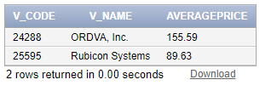

**select v.v_code, v_name, round(avg(p_price), 2) as "AVERAGEPRICE"**

**from vendor v, product p**

**where v.v_code = p.v_code**

**group by v.v_code, v_name**

**having avg(p_price) > (select avg(p_price) from product)**

**order by avg(p_price) desc**

1. **Provide a list of products that have a price that is greater than the average price of all products. Limit the results to those where the indate was in the month of December. Display the product code, product description, product price, and the difference between the price and the average price.**

**Subquery – WHERE clause**

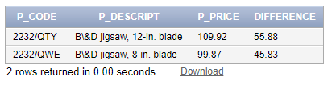

**select p_code, p_descript, p_price, to_char(p_price - (select avg(p_price) from product), '99.99') as "DIFFERENCE"**

**from product**

**where p_price > (select avg(p_price) from product)**

**and extract(month from p_indate) = 12**

1. **Provide a list of products and for each product display the product code, the description, and the total number of items sold for each product. Order by total sold.**

**To determine total number of items sold for each product – sum the line_units for that product)**

**Correlated subquery**

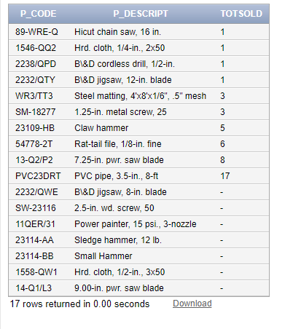

**select p_code, p_descript, (select sum(line_units)**

**from line l**

**where l.p_code = p.p_code) as "TOTSOLD"**

**from product p**

**order by TOTSOLD**

BONUS:

**List all the customers who have made purchases. Use the EXISTS keyword and a subquery.**

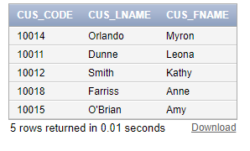

**select cus_code, cus_lname, cus_fname**

**from customer c**

**where exists (select distinct c.cus_code from invoice i where c.cus_code = i.cus_code)**

